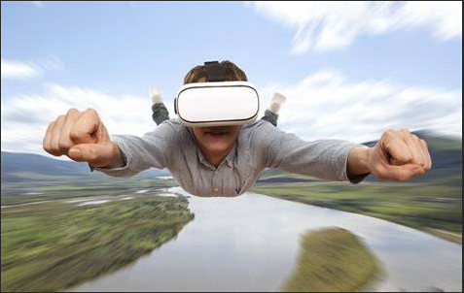

**Virtual Reality**

1. **What is VR (Virtual Reality)?**
2. Virtual-Reality as "an artificial environment which is experienced through sensory stimuli (as sights and sounds) provided by a computer and in which one's actions partially determine what happens in the environment."
3. (I.e. [video games](https://en.wikipedia.org/wiki/Video_game)) and educational purposes (i.e. medical or military training). Other, distinct types of VR style technology include [augmented reality](https://en.wikipedia.org/wiki/Augmented_reality) and [mixed reality](https://en.wikipedia.org/wiki/Mixed_reality), sometimes referred to as [extended reality](https://en.wikipedia.org/wiki/Extended_reality) or XR.
4. Currently standard virtual reality systems use either [virtual reality headsets](https://en.wikipedia.org/wiki/Virtual_reality_headset) or multi-projected environments to generate realistic images, sounds and other sensations that simulate a user's physical presence in a virtual environment.
5. A person using virtual reality equipment is able to look around the artificial world, move around in it, and interact with virtual features or items. The effect is commonly created by VR headsets consisting of a [head-mounted display](https://en.wikipedia.org/wiki/Head-mounted_display) with a small screen in front of the eyes, but can also be created through specially designed rooms with multiple large screens.
6. Virtual reality typically incorporates [auditory](https://en.wikipedia.org/wiki/Auditory_feedback) and [video feedback](https://en.wikipedia.org/wiki/Video_feedback), but may also allow other types of sensory and force feedback through [haptic technology](https://en.wikipedia.org/wiki/Haptic_technology).
7. **How Virtual Reality Works?**
   1. The primary subject of virtual reality is simulating the vision.
   2. Every headset aims to perfect their approach to creating an immersive 3D environment.
   3. Each VR headset puts up a screen in front of eyes thus, eliminating any interaction with the real world.
   4. Two autofocus lenses are generally placed between the screen and the eyes that adjust based on individual eye movement and positioning.
   5. The visuals on the screen are rendered either by using a mobile phone or HDMI cable connected to a PC.
   6. To create a truly immersive virtual reality there are certain prerequisites – a frame rate of minimum 60fps, an equally competent refresh rate and minimum 100-degree field of view (FOV) (though 180 degrees is ideal).
   7. The frame rate is the rate at which the GPU can process the images per second, screen refresh rate is the pace of the display to render images, and FOV is the extent to which the display can support eye and head movement.
8. Difference between VR and AR?
9. Virtual reality and augmented reality accomplish two very different things in two very different ways, despite the similar designs of the devices themselves.
10. VR replaces reality, taking you somewhere else. AR adds to reality, projecting information on top of what you're already seeing.
11. They're both powerful technologies that have yet to make their mark with consumers, but show a lot of promise. They can completely change how we use computers in the future, but whether one or both will succeed is anyone's guess right now

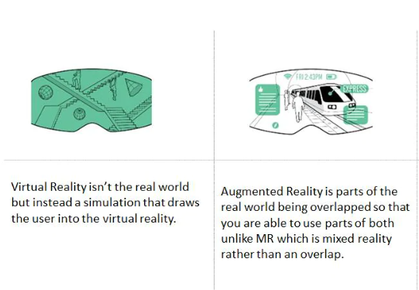



1. **How do I create Content for Virtual Reality?**
2. We first need to understand the types of content that are played in Virtual Reality
   1. Image
   2. Video
   3. Live 3D rendered Model
3. Each of the above content types can be either Monoscopic or Stereoscopic in visual presentation.



1. Stereoscopic content will give the perception of depth and which gives more immersion. Monoscopic content will be a flat image/video surrounding the user.

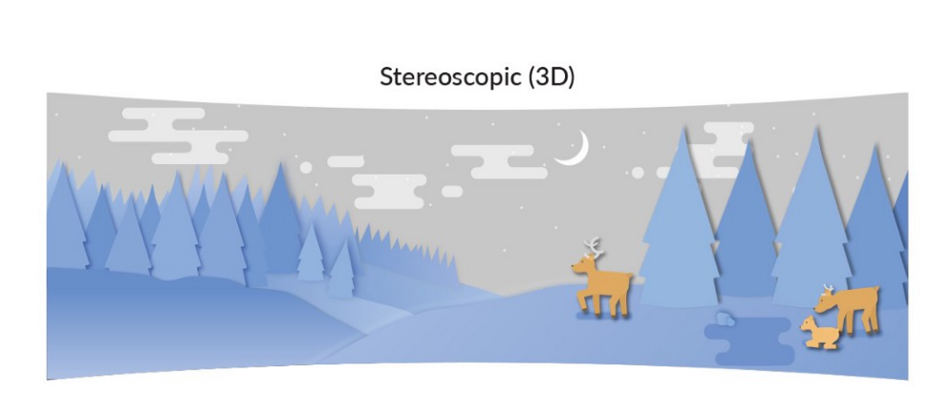

1. The content for VR is created either using camera and/or software.
2. Camera (Monoscopic or Stereoscopic)
   1. A normal phone camera :
      1. This makes us move our phone around clicking one picture each in different angles and then a software/app stitches all of them together.
      2. It can give us a 360 image only and not video.
      3. Example Google Cardboard camera app.
   2. A 360 camera or a Grid setup for multiple cameras will capture a 360 view
      1. This captures images from different sides/angles and gives one single image or video.
      2. The output of these camera is an equirectangular image or video
3. Software tools for Content creation
   1. 3D modeling software like 3DSMax, Maya, Blender, etc. are used to create a 3D environment.
4. Once the 3d model of the environment is ready, export or render option is used to give final output of image or video.
5. **Which is the best platform for VR?**

* Virtual reality is epic to the serious gamer. You can step inside the game and often manipulate your surroundings. Placing a VR headset on is stepping into another world, and your game world will be as real as your non-game world.
* Choosing the best headset for you depends on several factors. In this review, we discuss which headsets are the most affordable, easiest to use, and perfect for your level of gaming. This is the reality of the virtual experience.
* [Oculus Quest](https://www.digitaltrends.com/vr-headset-reviews/oculus-quest-review/) **headset is the best platform for VR**
* One of the biggest hurdles for virtual reality adoption is the ease of use. The Oculus Quest solves almost all of the problems that previously discouraged potential VR explorers. It doesn’t require any exterior sensors. It includes motion controllers, all the onboard processing it needs, and a full six-degree freedom-of-movement. Best of all, there are no wires tethering you to a PC. And best experience to play with Oculus Quest headset



1. **SWOT Analysis**

|  |  |
| --- | --- |
| Strengths | Opportunities |
| Easy And Intuitive interaction with VR System.  New technologies.  Easy and simple visualization of 3D Models and other data.  Free VR engines and 3D modeling Applications | Creations and modifications of VR systems using student ideas.  Development of application that uses 3D interfaces.  Simplifications in the process of creation of new VR systems and devices. |
| Weaknesses | Threats |
| High Prices of 3D interfaces  HMD needs to be connected to PC with cables.  VR System Needs High Computational Powers | Insufficient funds for purchase of 3D interfaces.  High Prices of latest 3D interfaces.  Expensive repair of damaged hardware. |

1. What Is Mixed reality?
   1. Mixed reality is augmented reality’s younger sibling. Where augmented reality is delivered through a handheld mobile device i.e. a smartphone or a tablet, mixed reality is delivered through head mounted see-through glasses.
   2. Mixed Reality is the merge of real and virtual worlds to produce new environments and visualizations where physical and digital objects co-exist and interact in real time.
   3. For example – picture a surgeon having a digital overlay while performing an operation, providing detailed live information on the process and the current state of the patient like blood pressure and other vital insights.
   4. The term mixed reality was coined by Microsoft when they launched the Microsoft HoloLens in 2016. Apart from being head mounted mixed reality also stands out from augmented reality through a more advanced understanding of the physical space and ability to place holograms in that space.

